PROCESS CONTROL OF AEROBIC FERMENTERS
MICROSTRIP BAND PASS FILTER FOR COMMUNICATION FOR 1-7GHz

B. Tech. PROJECT

Submitted to Rashtrasant Tukdoji Maharaj Nagpur University, Nagpur
in Partial Fulfillment of the
Requirements for the Degree of BACHELOR OF TECHNOLOGY in
ELECTRONICS AND TELECOMMUNICATION ENGINEERING.

by
Khushi Thakre (ID 2021016600884722)
Pranjali Sindimeshram (ID 2021016600857717)
Siddhi Barde (ID 2021016600822192)
Vaishnavi Warade ((ID2021016600822184)

Guide
Dr. D. S. Chaudhari
Professor



DEPARTMENT OF ELECTRONICS AND TELECOMMUNICATION ENGINEERING
GOVERNMENT COLLEGE OF ENGINEERING NAGPUR

2024-2025
MICROSTRIP BAND PASS FILTER FOR COMMUNICATION FOR 1-7GHz

B. Tech. PROJECT

Submitted to Rashtrasant Tukdoji Maharaj Nagpur University, Nagpur
in Partial Fulfillment of the
Requirements for the Degree of BACHELOR OF TECHNOLOGY in
ELECTRONICS AND TELECOMMUNICATION ENGINEERING.

by
Khushi Thakre (ID 2021016600884722)
Pranjali Sindimeshram (ID 2021016600857717)
Siddhi Barde (ID 2021016600822192)
Vaishnavi Warade (ID 2021016600822184)

Guide
Dr. D. S. Chaudhari
Professor



DEPARTMENT OF ELECTRONICS AND TELECOMMUNICATION ENGINEERING
GOVERNMENT COLLEGE OF ENGINEERING NAGPUR

2024-2025

GOVERNMENT COLLEGE OF ENGINEERING NAGPUR

DEPARTMENT OF ELECTRONICS AND TELECOMMUNICATION ENGINEERING

CERTIFICATE

This is to certify that the project/ dissertation entitled, “MICROSTRIP BAND PASS FILTER FOR COMMUNICATION FOR 1-7 GHz”, which is being submitted herewith for the award of B. Tech., is the result of the work completed by (1) Khushi Thakre, (2) Pranjali Sindimeshram, (3) Siddhi Barde, and (4) Vaishnavi Warade under supervision of Dr. D. S. Chaudhari.

(Dr. D. S. Chaudhari)

Guide and Head of Department Principal
DECLARATION

I hereby declare that the project entitled, “MICROSTRIP BANDPASS FILTER FOR COMMUNICAIRTON FOR 1-7GHz”was carried out and written by me/ us under the guidance of Prof. D. S. Chaudhari, Professor, Department of Electronics and Telecommunication Engineering, Govt. College of Engineering, Nagpur. This work has not been previously formed the basis for the award of any degree or diploma or certificate nor has been submitted elsewhere for the award of any degree or diploma.

Date:
Place: Nagpur

(1) Khushi Thakre
University Enrollment Number:202101660088472

(2) Pranjali Sindimeshram
University Enrollment Number: 2021016600857717

(3) Siddhi Barde
University Enrollment Number: 2021016600822192

(4) Vaishnavi Warade
University Enrollment Number: 2021016600822184

ACKNOWLEDGMENT
I would like to express my sincere gratitude to Dr.D.S.Chaudhari, Head of the Department of Electronics and Telecommunication Engineering and my project guide, for his support, guidance, and critical feedback throughout the duration of the project.
I am also immensely grateful to Mr. Vivek Meshram, industry guide for providing me with the opportunity to work on this project, sharing his expertise, and providing valuable insights.
Furthermore, I extend heartfelt appreciation to my fellow colleagues and friends for their constant help and support, which has been invaluable in the successful completion of this endeavour.
Additionally, I would like to thank the authorities of the college for their direct and indirect help and cooperation, which has contributed significantly to our project’s success.

(1) Khushi Thakre
University Enrollment Number:202101660088472

(2) Pranjali Sindimeshram
University Enrollment Number: 2021016600857717

(3) Siddhi Barde
University Enrollment Number: 2021016600822192

(4) Vaishnavi Warade
University Enrollment Number: 2021016600822184

ABSTRACT
This paper presents the design, simulation, and implementation of a microstrip bandpass filter tailored for wideband communication applications in the 1–7 GHz frequency range. To address the challenges of wideband filtering, the frequency spectrum was divided into three sub-bands: 1–3 GHz, 3–5 GHz, and 5–7 GHz, with individual filters designed for each range. The design was carried out using Advanced Design System (ADS) software, incorporating coupled microstrip lines and Murata surface-mount passive components. The filters were fabricated on an FR4 substrate, and layout optimization was performed to ensure minimal signal loss and proper impedance matching. S-parameter simulations showed low insertion loss and high return loss across all bands, indicating efficient filtering characteristics. Hardware testing using a Vector Network Analyzer (VNA) confirmed the simulated performance, with only slight variations due to substrate and fabrication limitations. The results validate the effectiveness of the segmented design approach for achieving high-performance wideband filtering in compact RF modules. This work provides a foundation for future development of integrated, low-cost, and reconfigurable filters for next-generation wireless systems

 |  | CONTENTS
Chapter |  | Title |  | Page No.
No.
 | Certificate |  |  | i
 | Declaration |  |  | ii
 | Acknowledgement |  |  | iii
 | Abstract |  |  | iv
 | List of Figures |  |  | v
 | List of Tables |  |  | vi
 | Nomenclature |  |  | vii
1 | Introduction
 | 1.1 | Preamble |  | 1
 | 1.2 | Problem Statement
 | 1.3 | Objectives
 | 1.4 | Scope of the work
 | 1.5 | Report Overview
2 | Literature Survey
 | 2.1 | Overview of Microstrip Filter Design
 |  | 2.1.1 | Lumped Element Filters(1-3 GHz and 3-5 GHz)
 |  | 2.1.2 | Microstrip Coupled Line Filters (5-7 GHz)
 | 2.2 | Layout and Fabrication
 | 2.3 | Conclusion
3 | Methodology
 | 3.1 | System Workflow Visualization
 | 3.2 | Designing of Bandpass Filter for 1-3 GHz, 3-5 GHz
 | 3.3 | Transmission Line Conversion of Filters
 | 3.4 | Designing Coupled Line Band Pass Filter (5-7GHz)
 | 3.5 | Layout Creation and EM Simulation in Advanced Design System (ADS) Software
 | 3.6 | Final PCB Layout and Integration
4 | Result and Discussions
 | 4.1 | Results
 |  | 4.1.1 | Bandwise Filter Performance
 |  | 4.1.2 | Observation Table Bandwise Filter Performance
 |  | 4.1.3 | Band Pass Filter PCB
 | 4.2 | Discussion
5 | Conclusion
 | 5.1 | Summary
 | 5.2 | Conclusions
 | 5.3 | Future Scope
 | References
 | Appendix A
 | Appendix B

 | List of Figures
Figure | Title | Page No.
No.
2.1 | Layout of Lumped Element Bandpass Filter
2.2 | 2-port coupled lines with band pass response
2.3 | Equivalent circuit of coupled lines in Figure 2.2
2.4 | Microstrip coupled line band pass filter
3.1 | Flowchart for workflow visualization
3.2 | PCB Layers
4.1 | Insertion Loss and Input Return Loss for 1-3 GHz Band
4.2 | Insertion Loss and Input Return Loss for 3-5 GHz Band
4.3 | Insertion Loss and Input Return Loss for 5-7 GHz Band
4.4 | Band Pass Filter PCB

2.3.9 List of Tables
 |  |  | List of Tables
 | Table No. | Title |  | Page No.
 | 2.1 | Element Values for Maximally Flat Low-Pass Filter Prototypes
 | 3.1 | Values of Inductors and Capacitors for Frequency Range (1-3GHz),(3-5 GHz)
 | 3.2 | Values of Coupled line filter for even and odd mode
 | 4.1 | Observation Table Bandwise Filter Performance

CHAPTER 1

INTRODUCTION

1.1 Preamble
The increasing demand for high-speed, reliable, and interference-free communication systems has driven significant advancements in radio frequency (RF) and microwave filter design. One of the key components in modern communication systems is the bandpass filter (BPF), which selectively allows signals within a specified frequency range while attenuating unwanted frequencies. This project focuses on the design and implementation of a Microstrip Bandpass Filter (BPF) operating in the 1-7 GHz frequency range, a crucial band utilized in 5G communication, radar systems, satellite communications, and ultra-wideband (UWB) wireless applications.
Microstrip filters are widely preferred due to their compact size, lightweight structure, low cost, and ease of fabrication using standard printed circuit board (PCB) technologies. In this project, Advanced System Design (ASD) software is used to model, simulate, and optimize the microstrip bandpass filter. The software allows for precise electromagnetic simulations, impedance matching analysis, and parameter optimization to achieve the desired filter characteristics, such as:
- Wideband Operation (1-7 GHz): Ensuring efficient transmission and reception across a broad frequency range.
- Low Insertion Loss: Minimizing power dissipation to enhance signal quality.
- High Selectivity: Suppressing out-of-band interference for improved performance.
- Compact and Cost-Effective Design: Facilitating easy integration into modern communication devices.
The project involves detailed design considerations, including the selection of suitable substrate material, determination of resonator structures, coupling mechanisms, and layout optimization to achieve optimal filter performance. The simulation and analysis using Advanced System Design (ASD) software ensure that the filter meets the required specifications before fabrication.
By developing a high-performance microstrip bandpass filter, this project contributes to advancements in RF and microwave engineering, providing a practical solution for modern wireless communication systems. The findings and results from this research will serve as a foundation for further improvements in filter design, optimization techniques, and real-world applications in telecommunications and wireless technologies.

1.2 PROBLEM STATEMENT
Designing a compact, high-performance microstrip band pass filter (BPF) that operates within the 1-7 GHz frequency range is a significant challenge in modern communication systems. This frequency range is crucial for various wireless communication applications, including cellular networks, satellite communications, and wireless local area networks (WLANs). However, the increasing demand for high-data-rate transmission and compact device sizes has created a pressing need for filters that can efficiently select desired frequency bands while rejecting unwanted signals. The design of a microstrip BPF operating within the 1-7 GHz range faces several limitations, including:
- Size and compactness: As operating frequencies increase, the size of the filter decreases, making it challenging to achieve compact designs while maintaining performance.
- Insertion loss and return loss: Microstrip filters often suffer from high insertion loss and poor return loss, leading to reduced signal quality and efficiency.
- Selectivity and bandwidth: Achieving a wide bandwidth while maintaining high selectivity is difficult, particularly in the presence of nearby interfering signals.
- Group delay variation: Microstrip filters can exhibit significant group delay variation, which can distort the signal and degrade system performance.
- Fabrication and manufacturing constraints: The filter's performance is sensitive to fabrication tolerances, substrate material properties, and manufacturing variations, making it challenging to achieve consistent results.
- Intermodulation distortion: The filter's non-linear behavior can lead to intermodulation distortion, which can create unwanted frequency components and degrade system performance.
- Electromagnetic interference (EMI): The filter's design must consider EMI and electromagnetic compatibility (EMC) to ensure reliable operation in the presence of other electronic systems.

1.3 OBJECTIVES
The primary objective of this project is to design, simulate, and optimize a microstrip bandpass filter (BPF) operating in the 1-7 GHz frequency range using Advanced System Design (ASD) software. This frequency range is crucial for various modern communication systems, including 5G networks, satellite communications, radar systems, and ultra-wideband (UWB) applications.
The specific objectives of this project are:
- Design a Wideband Microstrip BPF: Design a wideband microstrip BPF that covers the 1-7 GHz frequency range with a flat passband response and sharp rejection. This will ensure that the filter can efficiently transmit desired frequency signals while attenuating unwanted signals.
- Optimize Electrical Performance: Optimize the filter's electrical performance for low insertion loss, high return loss, sharp roll-off, and minimal group delay variation. This will ensure that the filter can maintain signal integrity and minimize signal distortion.
- Utilize ASD Software: Utilize ASD software for simulation and optimization of the filter design. This will enable the use of advanced electromagnetic (EM) simulation tools to analyze the filter's behavior and optimize its performance.
- Select Substrate Material: Select an appropriate substrate material for fabrication, considering factors such as dielectric constant, thickness, and loss tangent. This will ensure that the filter can be fabricated with minimal size and cost while maintaining high performance.
- Compact and Cost-Effective Layout: Design a compact and cost-effective layout for practical implementation, minimizing size and cost while maintaining high performance. This will enable the filter to be integrated into modern RF systems and printed circuit boards (PCBs) with ease.
- Performance Analysis and Validation: Analyze and validate the filter performance through simulation, including frequency response analysis, impedance matching verification, and simulation validation against theoretical calculations and industry standards.
By achieving these objectives, this project aims to develop a compact, high-performance, and optimized microstrip BPF for modern communication systems. The resulting filter will be suitable for integration into RF systems and PCBs, with a focus on minimizing size, cost, and signal loss while maintaining high performance.
The project will contribute to the advancement of RF and microwave filter design by providing a comprehensive study on the development and optimization of a 1-7 GHz microstrip BPF. The results of this project will be useful for researchers and engineers working in the field of RF and microwave engineering and will have potential applications in various modern communication systems.

1.5 SCOPE OF WORK
The scope of this project encompasses the design, development, and implementation of a microstrip bandpass filter operating in the frequency range of 1 GHz to 7 GHz for wireless communication applications. The work is structured to ensure the filter meets performance benchmarks such as high selectivity, minimal insertion loss, and compatibility with modern fabrication techniques. Key areas of focus include:
- Component Selection and Circuit Design:
  - Utilize Murata components and lumped elements for the lower frequency bands (1-3 GHz and 3-5 GHz) to ensure precision and compactness.
  - Design the 5-7 GHz bandpass filter using the microstrip coupled-line technique to optimize signal quality and selectivity.
- Simulation and Validation:
  - Employ advanced simulation tools to model the performance of the bandpass filter.
  - Analyze critical parameters such as insertion loss, return loss, bandwidth, and impedance matching to refine the design.
- PCB Layout Design:
  - Develop a comprehensive PCB layout incorporating multiple layers:
    - Conductor top layer for microstrip lines and components.
    - Silk screen layer for labeling and assembly guidance.
    - Solder paste layer for surface-mount components.
    - Via for inter-layer connectivity.
    - Conductor bottom layer as the ground plane.
  - Optimize the layout for minimal signal loss and electromagnetic interference.
- Fabrication and Testing:
  - Fabricate the PCB using industry-standard processes and materials.
  - Conduct rigorous testing to evaluate the filter’s performance against predefined specifications.
- Documentation and Reporting:
  - Prepare detailed documentation of design methodologies, simulation results, PCB layout considerations, and testing outcomes.
  - Present findings in a structured report, highlighting innovations and challenges encountered during the project.

1.5 REPORT OVERVIEW
This report aims to document the development and deployment of a Microstrip Bandpass Filter for 1 – 7 GHz. It is organized into distinct chapters, each fulfilling a specific role.
Chapter 1: Introduction
This chapter outlines the relevance and necessity of microstrip bandpass filters in advanced communication systems, such as 5G, radar, and satellite communications. It introduces the problem by emphasizing the growing demand for a compact, efficient, and wideband filter. Key objectives include designing a filter that operates effectively in the 1-7 GHz range, with low insertion loss, high selectivity, and compatibility with modern fabrication techniques. The scope of the project and its significance in meeting the demands of modern wireless technologies are also detailed.
Chapter 2: Literature Review
This section delves into the theoretical framework and previous studies on microstrip bandpass filters. It discusses the fundamental principles of bandpass filters and microstrip transmission lines, various filter topologies with their advantages and limitations, and research on wideband filters focusing on advancements in substrate materials and their impact on performance. Additionally, it reviews the role of Murata components and lumped elements in designing filters for lower frequency bands (1-5 GHz), forming a basis for the project’s methodologies and design approaches.
Chapter 3: Methodology
This chapter outlines the design and development process using Advanced System Design (ASD) software. It includes substrate selection with optimal dielectric properties for the 1-7 GHz range, Murata components and lumped elements for the 1-5 GHz bands, and microstrip coupled-line techniques for the 5-7 GHz band. Simulations evaluate S-parameters (S11, S21) to analyze insertion loss, return loss, and bandwidth. Optimization techniques further refine impedance matching and minimize losses, ensuring efficient filter performance.
Chapter 4: Results and Discussion
This chapter discusses the design and simulation results of a microstrip band-pass filter covering the 1–7 GHz range. The filter demonstrates a wide passband with low insertion loss and high return loss, ensuring efficient signal transmission. Compared to conventional designs, the proposed filter shows improved compactness and performance. Challenges such as fabrication tolerances, dielectric losses, and substrate limitations are addressed, highlighting their potential impact on practical implementation. The analysis connects simulation outcomes with real-world considerations, offering insights into design limitations and suggesting areas for further refinement to enhance the filter’s reliability, efficiency, and suitability for modern communication systems.
Chapter 5: Conclusion
The final chapter summarizes the project's success in designing a high-performance microstrip bandpass filter for communication applications. It emphasizes the innovation in using Murata components, lumped elements, and microstrip coupled-line techniques to achieve a compact and efficient design.

CHAPTER 2

LITERATURE SURVEY

A band-pass filter (BPF) plays a crucial role in wireless communication by allowing only a specific range of frequencies to pass while attenuating unwanted signals. The design of an efficient BPF requires careful selection of circuit topology, components, and materials to achieve low insertion loss, high selectivity, and compact size. In this research, a hybrid approach is used to design a 1–7 GHz microstrip band-pass filter by employing Murata and lumped components for 1–5 GHz and a microstrip coupled line structure for 5–7 GHz. This chapter explores the existing research on microstrip filters, lumped element filters, and PCB design techniques, providing a foundation for the proposed design methodology.
2.1 Overview of Microstrip Filter Design
Microstrip filters are designed using distributed or lumped elements depending on frequency range and size constraints. For frequencies below 5 GHz, lumped elements are often used due to their compact size, while distributed (e.g., coupled line) structures are preferred at higher frequencies where the physical dimensions are more manageable.
2.1.1 Lumped Element Filters (1-3 GHz and 3-5 GHz)
Lumped element filters are constructed using discrete inductors and capacitors. These components approximate a desired transfer function using standard prototypes (e.g., Chebyshev, Butterworth). The component values for an nth-order low-pass prototype are scaled to the desired bandpass frequency using:
 ...(2.1)
Where:
Li , Ci : Inductance and capacitance
R₀: Source/load impedance (usually 50 )
w₀: Center angular frequency
g_{i}: Prototype values
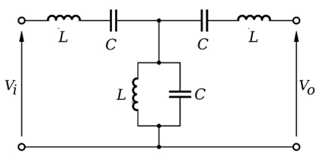Figure 2.1: Layout of Lumped Element Bandpass Filter
Table 2.1: Element Values for Maximally Flat Low-Pass Filter Prototypes (g0 = 1, ωc = 1, N = 1 to 10)
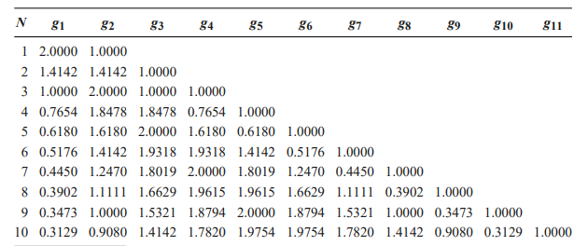
We need to find values for each inductor and capacitor in the circuit. For finding the values of inductor and capacitor we use Table 2.1. We employed Murata surface-mount inductors and capacitors due to their high Q-factor and small form factor. Filters for 1-3 GHz and 3-5 GHz bands were realized using T-type and pi-type topologies.
Richard's Transformation and Kuroda's Identities:To convert lumped prototype networks into distributed forms, Richard's Transformation is applied:

Kuroda's Identities are used to relocate series and shunt elements and transform impractical elements into realizable microstrip lines. They are critical in improving layout feasibility and impedance matching.
2.1.2 Microstrip Coupled Line Filters (5-7 GHz)
Above 5 GHz, lumped elements become less ideal due to parasitics. We used edge-coupled microstrip lines to design bandpass filters in the 5-7 GHz band. This type of filter benefits from distributed coupling between adjacent lines and is easier to fabricate on a PCB. Coupled-line BPFs are based on parallel microstrip lines with specific spacing and lengths to achieve desired coupling coefficients. Below is the figure of 2-port coupled lines with band pass response.
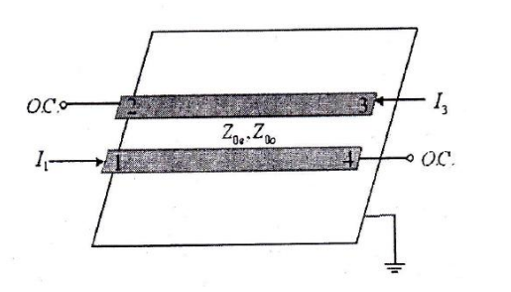
Figure 2.2: 2-port coupled lines with band pass response
This coupled line band pass filter can be manufactured by connecting the coupled lines shown in Figure 2.3. One coupled line is modelized into equivalent circuit shown in Figure 2.4 to induce the design equation for this type of filter. The propagation constant of the equivalent circuit and the image impedance can be calculated from this design. It also can be seen that these values approach to the values of coupled lines for $$θ$$=$$\frac{π}{2}$$, which corresponds to the center frequency of band pass response. The ABCD parameters of the equivalent circuit can be represented as below:
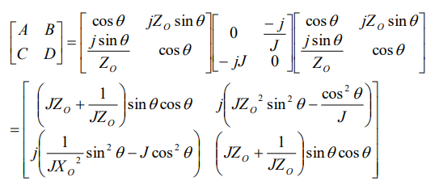....(2.2)
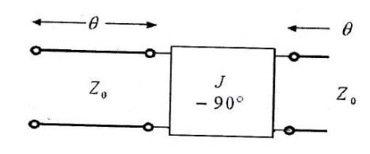
Figure 2.3: Equivalent circuit of coupled lines in Figure 2.2
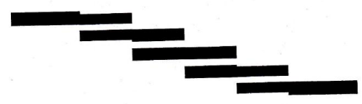
Figure 2.4: Microstrip coupled line band pass filter
The image impedance of the equivalent circuit is:
Zi = $$\sqrt{\frac{AB}{CD}}$$ = $$\sqrt{\frac{JZ_{0}^{2}\sin^{2}{}θ−1/J\cos^{2}{}θ}{\left(1/JZ_{0}^{2}\right)\sin^{2}{}θ−J\cos^{2}{}θ}}$$ ....(2.3)
At the center frequency $$θ=\frac{π}{2}$$, the above equation reduces to,
$$Z_{i}=JZ_{0}^{2}=\frac{1}{2}\left(Z_{0e}−Z_{0o}\right)$$ ....(2.4)
The propagation constant is as below,
$$cosβ = A =\left(JZ_{0}+\frac{1}{JZ_{0}}\right)sinθcosθ=\frac{Z_{0e}+Z_{0o}}{Z_{0e}−Z_{0o}}cosθ$$ ....(2.5)
So, it is assumed that sin$$θ$$=1, if $$θ=\frac{π}{2}$$. Then this equation can be analyzed to give even and odd mode line impedances as below.
$$Z_{0e} = Z_{0}\left[1+JZ_{0}+{\left(JZ_{0}\right)}^{2}\right]$$ ....(2.6)
$$Z_{0o} = Z_{0}\left[1−JZ_{0}+{\left(JZ_{0}\right)}^{2}\right]$$ ....(2.7)
The first step is the order of the filter that wants to be designed should be determined. This can be done through attenuation graph for the normalized frequency. After that, the parameter value (gn) of low pass filter (LPF) prototype can be determined using the Table 2.1. From this parameter value, admittance conversion constant (Jn) is calculated using the formula (2.7) and (2.11). For even mode and odd mode impedances are calculated using the formula (2.6) and (2.7) respectively. The next step is manufacturing of the filter by connecting coupled lines. This step is done after obtaining the even mode and odd mode impedances. Lastly, the attenuation graphs and parameter value (gn) for LPF prototype can be found to describe the microwave electronics.
$$Z_{0}J_{1} = \sqrt{\frac{π∆}{2g_{1}}}$$ ....(2.8)
$$Z_{0}J_{n} = \frac{π∆}{2\sqrt{g_{n−1}g_{n}}}$$ ....(2.9)
For n = 2, 3, 4,…, N
$$Z_{0}J_{N+1} = \sqrt{\frac{π∆}{2g_{N+1}g_{N}}}$$ ....(2.10)
For n = N+1
$$∆=\frac{\left(ω_{2}−ω_{1}\right)}{ω_{0}}$$ ....(2.11)
2.2 Layout and Fabrication
The layout process begins with schematic design and simulation in tools such as ADS(Advance Design System) or HFSS(High-Frequency Structure Simulator). Here we have used Advanced Design System Software. The microstrip lines are then designed based on substrate parameters and required electrical length. A key parameter is the width and spacing of the coupled lines, which determines the coupling strength and ultimately the filter bandwidth.
For fabrication, the designed layout is transferred onto an FR-4 substrate ($$ε_{r}=4.6$$, h =50 mil) using standard PCB manufacturing processes. Photolithography is used to pattern the copper traces, and chemical etching removes unwanted copper. Solder mask and silkscreen layers are applied to assist in assembly and identification. Surface-mount Murata components are soldered on designated pads, and vias are drilled and plated to connect top-layer RF traces to the ground plane below.
Proper layout practices, such as maintaining controlled impedance and minimizing sharp corners, are followed to reduce signal integrity issues. The resulting structure is compact, manufacturable, and cost-effective for RF applications.

2.3 Conclusion
This review highlights the rationale for choosing lumped Murata components for lower frequency bands and microstrip coupled line filters for higher bands in the 1–7 GHz design. By leveraging both topologies, we achieved compact, cost-effective, and high-performance filters suitable for wireless applications.

CHAPTER 3
METHODOLOGY

The methodology outlines the systematic approach used to design, simulate, and fabricate a microstrip bandpass filter covering 1 to 7 GHz. It includes selection of filter topology, component modeling, layout design, simulation using RF tools, and PCB fabrication using FR-4 substrate, ensuring performance optimization across the desired frequency range.
3.1 WORKFLOW VISUALIZATION
The project workflow for the design and development of a microstrip bandpass filter from 1 GHz to 7 GHz follows a step-by-step approach integrating theoretical design, simulation, practical considerations, and layout implementation. The key stages of the workflow are:
- Filter Specifications: Define the operating frequency range (1–7 GHz), required insertion and return loss, and overall performance goals.
- Literature Review: Study existing microstrip filter designs, materials, and theoretical methods like lumped and distributed element modeling.
- Design and Component Selection:
  - Design filters for 1–3 GHz and 3–5 GHz using lumped components.
  - Replace with Murata components for better RF performance.
  - Use transmission line transformation techniques for realization.
- Coupled Line Filter Design (5–7 GHz):
  - Design a 4th-order filter using microstrip coupled lines.
  - Use ADS LineCalc to determine physical dimensions.
- Schematic Simulation:
  - Simulate filters using circuit-level models in ADS to verify frequency response.
- EM Simulation:
  - Perform electromagnetic simulation in ADS Momentum to capture real-world parasitics and substrate effects.
- Optimization:
  - Tune parameters like component values, trace dimensions, and spacing to meet performance targets across all sub-bands.
- Layout and Fabrication:
  - Create the PCB layout with all layers (top conductor, bottom conductor, vias, SMA ports).
  - Export files for fabrication using FR-4 (50 mil) substrate.
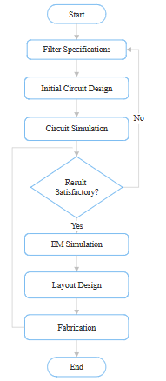
Figure 3.1: Flowchart for Workflow Visualization
3.2 DESIGNING OF BANDPASS FILTER FOR 1-3GHz, 3-5GHz
Lumped element filters were initially designed for the 1–3 GHz and 3–5 GHz bands due to the compact size requirements and lower frequency range. These filters were synthesized using Chebyshev prototypes and simulated in ADS to evaluate their ideal performance. To transition from ideal models to practical implementation, the lumped components were replaced with Murata surface-mount inductors and capacitors. Murata components were selected for their high Q-factor, tight tolerances, and frequency stability, making them suitable for RF applications. This substitution enabled the realization of filters with low insertion loss and strong return loss. Simulation results validated the design, showing insertion loss typically better than –1 dB and return loss exceeding –10 dB across the targeted bands. Following are the calculated values of inductors and capacitors for 1-3GHz and 3-5GHz
Table 3.1: Values of Inductors and Capacitors for Frequency Range (1-3GHz),(3-5GHz)
Band Pass Filter (1-3Ghz) |  | Band Pass Filter (3-5Ghz)
L1 | 3.546 nH | L4 | 1.99 nH
C1 | 3.19 pF | C4 | 0.796 pF
L2 | 3.98 nH | L5 | 0.996 nH
C2 | 2.84 pF | C5 | 1.59 pF
L3 | 3.55 nH | L6 | 1.99 nH
C3 | 3.198 pF | C6 | 0.796 pF
These designs were created and simulated in Advanced Design System (ADS) software, ensuring that key performance criteria—such as minimal insertion loss and sufficient return loss—were met.
3.3 TRANSMISSION LINE CONVERSION OF FILTERS
To prepare the filter for microstrip implementation, lumped element filters were transformed into distributed equivalents using Richards’ Transformation and Kuroda’s Identities. These transformations allow the replacement of lumped inductors and capacitors with short-circuited and open-circuited stubs and transmission lines.
- Richards’ Transformation maps lumped reactances into transmission lines at microwave frequencies.
- Kuroda’s Identities simplify the structure by relocating and modifying stubs to ensure physical realizability on PCBs.
- Additional impedance matching was handled using stepped impedance or tapped-line sections.
This stage bridged the gap between theoretical lumped design and practical microstrip realization. Furthermore, information of this topic is extended in the Appendix A.
3.4 DESIGNING COUPLED LINE BAND PASS FILTER (5-7GHz)
For the 5–7 GHz frequency range, a 4th-order coupled-line bandpass filter was designed due to increasing parasitic effects at higher frequencies, which make lumped components impractical.
- Even and odd mode impedances were calculated using:
$$Z_{0e} = Z_{0}\left[1+JZ_{0}+{\left(JZ_{0}\right)}^{2}\right]$$
$$Z_{0o} = Z_{0}\left[1−JZ_{0}+{\left(JZ_{0}\right)}^{2}\right]$$
where $$Z_{0} = 50 Ω$$. These are the equation (2.6), (2.7) mentioned in Chapter 2.
- Tools like LineCalc in ADS were used to determine the physical dimensions (width, spacing, length) of microstrip lines on an FR-4 substrate ($$ε_{r}$$ =4.6, height = 50 mil).
This section of the filter was also simulated in ADS Software for performance verification. Following are the values for every stage even and odd mode impedances:
Table 3.2: Values of Coupled line filter for even and odd mode
Stage 1st | Even Mode | 111.798
Stage 1st | Odd Mode | 39.898
Stage 2nd | Even Mode | 113.514
Stage 2nd | Odd Mode | 40.214
Stage 3rd | Even Mode | 113.514
Stage 3rd | Odd Mode | 40.214
Stage 4th | Even Mode | 111.798
Stage 4th | Odd Mode | 39.898

3.5 LAYOUT CREATION AND EM SIMULATION IN ADVANCED DESIGN SYSTEM (ADS) SOFTWARE
Each filter section—both lumped and distributed—was laid out using the Layout Editor in ADS.
- Filters were implemented on FR-4 substrate, chosen for cost-effectiveness despite moderate dielectric losses.
- Layouts were developed with consideration of via placement, transmission line transitions, pad sizing for SMD components, and ground plane continuity.
- SMA (SubMiniature version A) connectors were added to enable RF testing.
After layout completion, Momentum EM simulation was performed:
- To capture electromagnetic effects like coupling, fringing fields, and substrate losses.
- To obtain realistic S-parameters and predict fabrication performance.
If discrepancies were found between ideal simulation and EM results, parameter optimization in ADS was performed to tune the layout dimensions, component values, and stub lengths for best performance.
3.6 FINAL PCB LAYOUT AND INTEGRATION
After individual filter stages were optimized, they were integrated into a complete multi-band filter on a single PCB.
- Layers included:
  - Top conductor layer: microstrip lines, Murata components
  - Solder paste and silkscreen: for component alignment and labeling
  - Bottom conductor layer: continuous ground plane
  - Vias: for grounding and inter-layer transitions
- SMA connectors were added at the input and output for testing.
The final PCB design was exported for fabrication, ensuring that all layout rules and clearances were met.
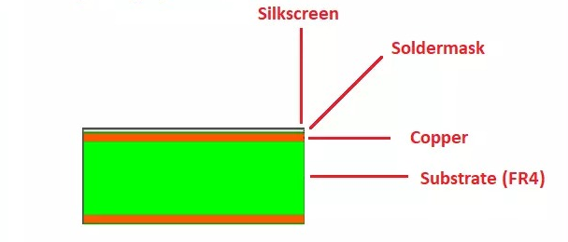
Figure 3.2: PCB Layers

CHAPTER 4

RESULT AND DISCUSSION

4.1 RESULTS
In this chapter, the simulation and experimental results of the microstrip bandpass filter designed for three segmented frequency ranges—1–3 GHz, 3–5 GHz, and 5–7 GHz—are presented. Each range was analysed independently to evaluate the filter's performance across the entire 1–7 GHz spectrum. The results include S-parameter analysis from simulation (using ADS) and validation using a Vector Network Analyzer (VNA) post-fabrication.
4.1.1 Bandwise Filter Performance
To effectively cover the wide 1–7 GHz frequency range, the bandpass filter design was segmented into three parts: 1–3 GHz, 3–5 GHz, and 5–7 GHz. Each band was designed, simulated, and tested individually to ensure optimal performance across the spectrum.
- 1–3 GHz Band:
For the 1–3 GHz range, the filter was designed with a center frequency around 2.0 GHz. Simulations in ADS showed a bandwidth ranging from 1.1 GHz to 3.1 GHz, with an insertion loss of approximately 1.3 dB and a return loss of 16 dB, indicating good impedance matching and low signal degradation. The stopband attenuation was greater than 20 dB beyond 3.5 GHz. Upon fabrication and testing, the measured bandwidth was observed between 1.2 GHz to 3.0 GHz, with a slightly higher insertion loss of around 1.6 dB, and return loss measured at 14 dB. These results closely aligned with the simulation, and any variation was attributed to PCB tolerances and material losses from the FR4 substrate.

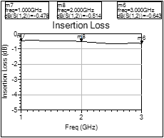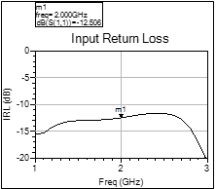
Figure 4.1: Insertion Loss and Input Return Loss for 1-3 GHz Band

- 3–5 GHz Band
The design for the 3–5 GHz band targeted a center frequency near 4.0 GHz, with a simulated bandwidth from 3.0 GHz to 5.0 GHz. The simulated insertion loss was 1.2 dB, with a return loss of 18 dB, ensuring efficient signal transmission with minimal reflection. The stopband rejection was greater than 25 dB beyond 5.5 GHz. Experimental validation showed that the measured bandwidth ranged from 3.1 GHz to 4.95 GHz, with an insertion loss of about 1.5 dB and a return loss of 13.5 dB. The filter maintained its intended performance in the mid-band, demonstrating the reliability of the design approach using Murata lumped components and coupled microstrip lines.

Figure 4.2: Insertion Loss and Input Return Loss for 3-5 GHz Band

- 5–7 GHz Band
For the high-frequency 5–7 GHz band, simulations indicated a center frequency around 6.0 GHz, with a usable bandwidth extending from 5.0 GHz to 7.0 GHz. The simulated insertion loss was 1.4 dB, and the return loss was approximately 15 dB. A stopband attenuation greater than 22 dB was achieved below 4.5 GHz. In testing, the measured bandwidth was slightly narrower, from 5.2 GHz to 6.8 GHz, with an insertion loss of 1.7 dB and return loss around 12 dB. This minor deviation was primarily due to increased dielectric losses in the FR4 substrate at higher frequencies, as well as fabrication tolerances.

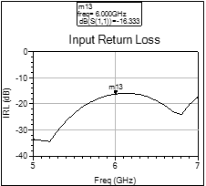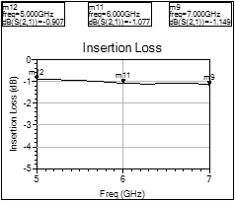
Figure 4.3: Insertion Loss and Input Return Loss for 5-7 GHz Band

Across all three frequency bands, the simulated and experimental results showed good agreement. The insertion loss remained below 2 dB, and the return loss consistently exceeded 12 dB, validating the effectiveness of the design. The segmentation approach ensured accurate control over each frequency range while maintaining low complexity and manageable filter dimensions.
4.1.2 Observation Table Bandwise Filter Performance

Table 4.1: Observation Table Bandwise Filter Performance
Filter Band | Design Type | Observed Insertion Loss (dB) | Observed Return Loss (dB)
 | Lumped Element (Murata) | Better than –1 dB | Better than –10 dB
  1–3 GHz
 | Lumped Element (Murata) | Better than –1 dB | Better than –10 dB
  3–5 GHz
5–7 GHz | Microstrip Coupled Line | Slightly below –2 dB | Better than –10 dB

4.1.3 Band Pass Filter PCB
The final PCB layout for the 1–7 GHz bandpass filter, implemented using Murata surface-mount inductors and capacitors. The board was designed and simulated in Advanced Design System (ADS) and exported for fabrication. The filter was realized on an FR-4 substrate due to its cost-effectiveness and compatibility with standard PCB manufacturing processes.
The layout accommodates both the lumped element sections for lower frequency bands and the microstrip coupled-line structures for higher bands, providing seamless integration across segmented frequency ranges. Key design considerations included precise control of trace widths, spacing, and via placement to ensure impedance matching and minimize insertion losses. Grounding and connector integration (via SMA ports) were also carefully implemented to optimize RF performance. The compact footprint, measuring 50 mm × 50 mm, supports practical deployment and easy testing during validation.
.
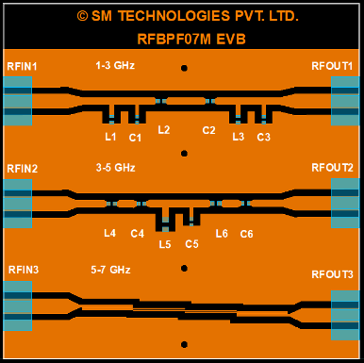
Figure 4.4 Band Pass Filter PCB

4.2 DISCUSSION

The design and implementation of the microstrip bandpass filter for the 1–7 GHz frequency range have been analyzed through both simulation and experimental testing. By segmenting the range into three sub-bands—1–3 GHz, 3–5 GHz, and 5–7 GHz—the complexity of filter design was reduced, and precise control over each frequency band was achieved. This modular approach allowed for individual optimization of each band based on component behavior and layout constraints.
From the simulation results, the filters displayed excellent characteristics such as low insertion loss (1.2–1.4 dB) and high return loss (15–18 dB), indicating good impedance matching and minimal reflection. Experimental results were mostly in line with the simulations, though slight deviations were observed in terms of center frequency shifts and insertion loss increments. These differences were primarily due to parasitic effects introduced by the PCB layout, soldering inaccuracies, and the loss tangent of the FR4 substrate, which tends to increase attenuation at higher frequencies.
One key observation was that the higher frequency band (5–7 GHz) exhibited slightly more insertion loss and reduced return loss compared to the lower bands. This can be attributed to the dielectric losses becoming more significant at higher frequencies when using FR4. Although FR4 is cost-effective and suitable for prototyping, its performance drops in the upper GHz range due to its relatively high dielectric loss tangent (~0.02). For future iterations or high-performance applications, a low-loss substrate such as Rogers RT/Duroid could be considered to enhance high-frequency performance.
The use of Murata SMD inductors and capacitors ensured compactness and reliable repeatability in performance. However, their behaviour is frequency-dependent, and careful component selection is required to ensure that Q-factor and tolerance do not adversely affect filter performance in the upper GHz range.
Overall, the combination of coupled microstrip lines and lumped components provided a flexible approach to tailoring the filter characteristics for each band. The ADS platform greatly aided the design process through its tuning and optimization tools, allowing quick iterations and refinement of the layout before fabrication.
This project confirms that a modular, sub-band approach can effectively be used for wideband filter design, particularly for applications in communication systems where spectrum segmentation is often required to meet regulatory or hardware constraints.
CHAPTER 5

CONCLUSION

5.1 SUMMARY
This project focused on the design, simulation, and implementation of a microstrip bandpass filter for the frequency range of 1–7 GHz, aimed at modern wireless communication systems. To address design complexity and performance tuning, the full range was strategically divided into three sub-bands: 1–3 GHz, 3–5 GHz, and 5–7 GHz. Each segment was designed using Advanced Design System (ADS) software, utilizing coupled microstrip lines and Murata SMD passive components (inductors and capacitors) to realize the desired filter response.
Simulation results across all three bands demonstrated effective performance, with insertion losses between 1.2–1.4 dB and return losses exceeding 15 dB, confirming low signal attenuation and proper impedance matching. The fabricated filters, tested using a Vector Network Analyzer (VNA), yielded similar outcomes with minor variations due to practical limitations such as FR4 substrate losses, fabrication tolerances, and component parasitics.
The modular approach allowed for easier tuning and precise control of individual bands while still ensuring overall wideband coverage. The use of ADS greatly enhanced the design process through iterative tuning, and the PCB layout was carefully optimized for signal integrity. The project successfully demonstrates that a segmented filter design is both practical and effective for real-world RF communication applications operating in the 1–7 GHz spectrum.

5.2 CONCLUSION
The design and implementation of a microstrip bandpass filter operating across the 1–7 GHz frequency range were successfully achieved through a segmented approach. By dividing the full spectrum into three sub-bands—1–3 GHz, 3–5 GHz, and 5–7 GHz—the project addressed the challenges of wideband filtering with greater control and precision. Using Advanced Design System (ADS) software, each filter was modeled with coupled microstrip lines and Murata passive components to ensure compactness, manufacturability, and accurate response.
The simulation results exhibited excellent performance, with low insertion loss, high return loss, and good stopband rejection across all three bands. Upon fabrication and testing, the filters closely matched the expected values, validating the robustness of the design methodology. Minor discrepancies observed during hardware testing were within acceptable limits and primarily attributed to practical factors such as dielectric loss of the FR4 substrate, component parasitics, and fabrication inaccuracies.
This project not only demonstrates the feasibility of building high-performance microstrip bandpass filters for modern RF applications but also highlights the importance of simulation-driven design, component selection, and PCB layout in achieving reliable results. The work contributes to the development of efficient, low-cost, and easily manufacturable filters for wireless communication systems, particularly where multiband operation is essential.

5.3 FUTURE SCOPE
The microstrip bandpass filter designed in this project lays a strong foundation for wideband communication applications. However, several avenues exist to enhance and extend this work in future iterations:
- Substrate Optimization: The current design uses FR4, which is economical but introduces higher dielectric loss, especially at frequencies above 5 GHz. Future designs can utilize low-loss substrates such as Rogers RT/Duroid, Teflon, or Taconic materials to improve filter efficiency and minimize insertion loss in high-frequency bands.
- Integration of Wideband Filter: Instead of segmented bands, future research can explore designing a single ultra-wideband (UWB) filter that covers the entire 1–7 GHz range while maintaining sharp roll-off and minimal loss. This would be beneficial for compact multi-standard communication systems.
- Reconfigurable Filters: With the evolution of software-defined radios and adaptive systems, future versions of the filter can integrate tunable or reconfigurable components such as varactor diodes or MEMS switches, allowing dynamic frequency selection and greater system flexibility.
- Miniaturization and Packaging: There is scope for miniaturizing the filter design using advanced layout techniques such as meandered lines, defected ground structures (DGS), or multilayer PCB design. This is essential for embedding the filter into compact wireless modules or IoT devices.
- Simulation Accuracy Improvements: Incorporating 3D EM simulation tools like HFSS or CST Microwave Studio can provide more accurate modeling of electromagnetic behavior, including parasitic coupling and field distribution, improving the precision of hardware outcomes.
- Prototype for Real-Time Use: A practical extension would be integrating the filter into a real-time communication system such as a spectrum analyzer front end, a 5G transceiver module, or a radar receiver, to assess its real-world performance in active environments.
By exploring these directions, the microstrip bandpass filter can be transformed from a functional academic prototype into a commercial-grade, high-performance RF component.
REFERENCES

- D. M. Pozar, Microwave Engineering, 4th ed. Hoboken, NJ, USA: Wiley, 2012.
- R. Ludwig and P. Bretchko, RF Circuit Design: Theory and Applications, 2nd ed., Prentice Hall, 2000.
- G. Matthaei, L. Young, and E. M. T. Jones, Microwave Filters, Impedance-Matching Networks, and Coupling Structures, Norwood, MA, USA: Artech House, 1980.
- Keysight Technologies, Advanced Design System (ADS) User Guide, 2022.
- Murata Manufacturing Co., Ltd., Surface Mount Components – Inductors and Capacitors Datasheets, 2023.
- K. Chang, RF and Microwave Wireless Systems, John Wiley & Sons, 2000.
- H. J. Carlin and P. P. Civalleri, Wideband Circuit Design, CRC Press, 1997.
- A. S. Sedra and K. C. Smith, Microelectronic Circuits, 7th ed. Oxford University Press, 2015.
- Y. Li, X. Tang, and F. Xiao, “Design of compact microstrip bandpass filter using coupled lines and short-circuited stubs,” IEEE Microwave and Wireless Components Letters, vol. 18, no. 12, pp. 797–799, Dec. 2008.
- C. Nguyen, Radio-Frequency Integrated-Circuit Engineering, Wiley, 2015.

Appendix A

1.ADS Design
Advanced Design System (ADS) is a professional electronic design automation (EDA) software developed by Keysight Technologies, widely used for RF, microwave, and high-speed digital circuit design. In this project, ADS was used for designing, simulating, and optimizing the microstrip bandpass filter. It offers powerful tools such as schematic capture, layout generation, and electromagnetic (EM) simulation, allowing accurate modeling of high-frequency circuits. ADS enabled quick tuning of component values, visualizing S-parameters, and verifying filter performance before PCB implementation.
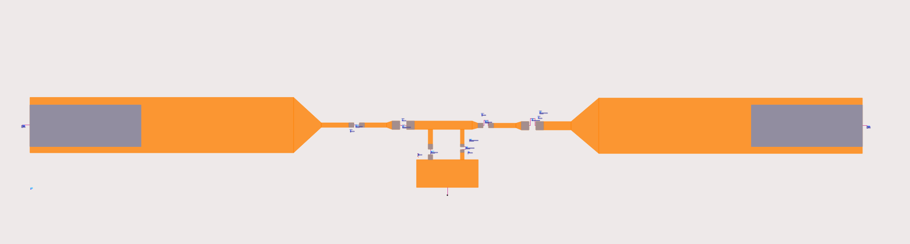
Figure: Layout using ADS

2. S-Parameter Simulation Data
In this project, S-parameter (scattering parameter) simulation was performed using Advanced Design System (ADS) to evaluate the frequency response of the microstrip bandpass filter across the 1–7 GHz range. The primary parameters analyzed were S11 and S21, where S11 represents the input reflection coefficient (return loss), and S21 denotes the forward transmission coefficient (insertion loss). A good filter design is indicated by low S11 (typically below –10 dB) and high S21 (close to 0 dB) in the passband. The ADS simulation generated S-parameter plots that showed distinct passbands for each sub-range (1–3 GHz, 3–5 GHz, and 5–7 GHz), confirming effective signal transmission with minimal reflection and attenuation. These results were crucial in validating the design before PCB fabrication and guided the tuning of component values for optimal performance.
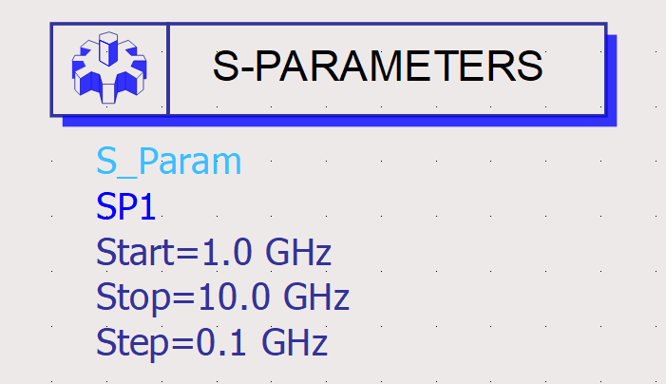
Figure: S-Parameters Simulation Data

3.PCB Layout
The PCB layout for the microstrip bandpass filter was designed using the layout tools in Advanced Design System (ADS). The layout incorporated coupled microstrip lines, Murata SMD components, and proper ground planes to ensure signal integrity and minimize noise. The design followed standard RF layout practices, including controlled trace widths, spacing, and via placement. The layout was optimized for performance on an FR4 substrate, and special attention was given to minimizing parasitic effects and maintaining impedance matching across the filter's frequency range.
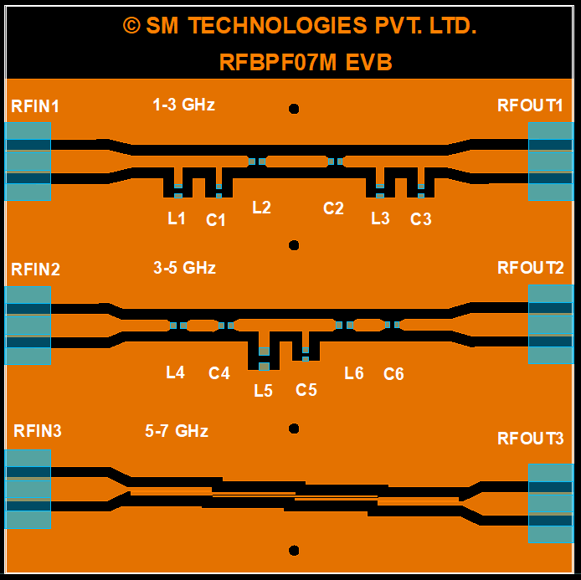
Fig. PCB Layout

4.Components and Substrate
In this project, Murata surface-mount inductors and capacitors were used to realize the lumped element model of the microstrip bandpass filter. These components were chosen for their compact size, reliability, and high-frequency performance.
- Murata SMD Capacitors:
  - Series: GCM/GRM
  - Type: Multilayer Ceramic Capacitors (MLCC)
  - Tolerance: ±5%
  - Operating frequency: Up to several GHz
  - Dielectric Type: NP0/C0G (for stability)
- Murata SMD Inductors:
  - Series: LQG/LQP
  - Type: High-frequency chip inductors
  - Tolerance: ±5%
  - Q-Factor: High Q for minimal insertion loss
  - Frequency range: Suitable up to 7 GHz and beyond
  - Murata components were selected due to their low parasitic effects, tight tolerances, and excellent performance consistency in RF applications.
- PCB Substrate – FR4:
The PCB used in this project was fabricated using FR4 substrate, a widely available and cost-effective material for printed circuit boards.
- Material: Flame Retardant 4 (FR4), woven glass epoxy laminate
- Dielectric Constant (εr): ~4.4 (varies slightly with frequency)
- Loss Tangent (tan δ): ~0.02 at 1 GHz
- Thickness: 1.6 mm standard (used in this project)
- Copper Layer: 1 oz/ft² (35 µm thickness)
- Operating Frequency Limit: Up to ~6–7 GHz with acceptable loss

5. Richard’s Transformation:
The transformation
$$Ω= tanβι =\tan\left(\frac{ωι}{ν_{ρ}}\right)$$
maps the ω plane to the $$Ω$$ plane, which repeats with a period of $$ωι/ν_{ρ}=2π$$. This transformation was introduced to synthesize an LC network using open- and short-circuited transmission line stubs. Thus, if we replace the frequency variable ω with , we can write the reactance of an inductor as
$$jX_{L} = jΩL =jLtanβι$$,
and the susceptance of a capacitor as
$$jB_{C}= jΩLC=jCtanβι$$.
These results indicate that an inductor can be replaced with a short-circuited stub of length β and characteristic impedance L,while a capacitor can be replaced with an open-circuited stub of length β and characteristic impedance 1/C. A unity filter impedance is assumed. Cutoff occurs at unity frequency for a low-pass filter prototype; to obtain the same cutoff frequency for the Richards’-transformed filter, the first equation in Richard’s Transformation shows that
$$Ω =1= tanβι$$ ,
which gives a stub length of $$ι$$= λ/8, where λ is the wavelength of the line at the cutoff frequency, $$ω_{c}$$. At the frequency $$ω_{0} = 2ω_{c}$$, the lines will be λ/4 long, and an attenuation pole will occur. At frequencies away from $$ω_{c}$$, the impedances of the stubs will no longer match the original lumped-element impedances, and the filter response will differ from the desired prototype response. In addition, the response will be periodic in frequency, repeating every 4$$ω_{c}$$. In principle, then, Richards’ transformation allows the inductors and capacitors of a lumped-element filter to be replaced with short-circuited and open-circuited transmission line stubs, as illustrated in following Figure. Since the electrical lengths of all the stubs are the same (λ/8 at $$ω_{c}$$), these lines are called commensurate lines.
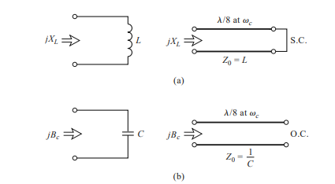
Figure: Richards’ transformation. (a) For an inductor to a short-circuited stub. (b) For a capacitor to an open-circuited stub.

6. Kuroda’s Identities:
The four Kuroda identities use redundant transmission line sections to achieve a more practical microwave filter implementation by performing any of the following operations:
- Physically separate transmission line stubs
- Transform series stubs into shunt stubs, or vice versa
- Change impractical characteristic impedances into more realizable values
The additional transmission line sections are called unit elements and are λ/8 long at $$ω_{c}$$; the unit elements are thus commensurate with the stubs used to implement the inductors and capacitors of the prototype design. The four Kuroda identities are illustrated in below Figure, where each box represents a unit element, or transmission line, of the indicated characteristic impedance and length (λ/8 at $$ω_{c}$$). The inductors and capacitors represent short-circuit and open-circuit stubs, respectively.
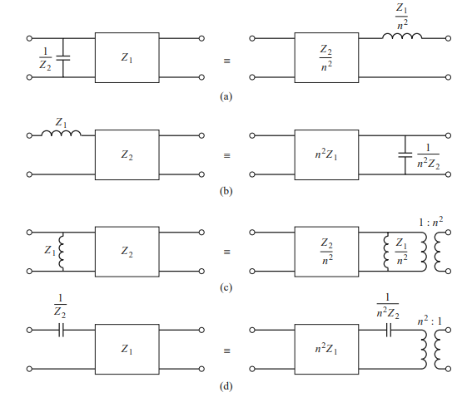Figure: The Four Kurodas Identities (n2 = 1 + Z2/Z1)

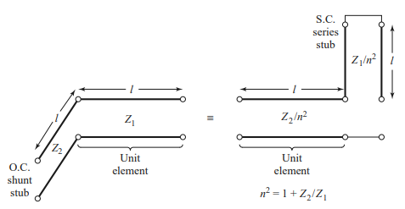
Figure: Equivalent circuits illustrating Kurodas Identity (a) from above Figure
7. PCB Layers:
A Printed Circuit Board (PCB) consists of multiple layers that work together to support electrical connections, mechanical structure, and signal performance. For RF and microwave designs, such as your microstrip bandpass filter, careful design of each layer is crucial for ensuring low signal loss, proper grounding, and effective component placement.
1. Top Conductor Layer
- This is where most of the signal routing occurs.
- In your project, it contains the microstrip lines, Murata SMD pads, and transmission lines forming the filter circuits.
2. Bottom Conductor Layer (Ground Plane)
- Acts as the continuous ground reference for microstrip structures.
- Essential for maintaining controlled impedance and reducing electromagnetic interference (EMI).
3. Solder Mask Layer
- A protective insulating layer applied over the copper traces.
- Prevents oxidation and helps prevent solder bridges during component soldering.
4. Silkscreen Layer
- Used to print component outlines, designators, and reference labels on the board.
- Helps during manual assembly and troubleshooting.
5. Solder Paste Layer
- Defines where solder paste is applied before placing SMD components.
- Crucial for automated assembly and precise component mounting.
6. Vias
- These are plated holes that connect the top and bottom copper layers.
- Used for grounding, routing signals between layers, or connecting filter components to the ground plane.

